Automotive Immersion Day Labs

This hands-on lab will guide you through a series of steps to showcase how AWS services fit into the context of Automotive. The labs will help you to understand device connectivity, data generation, real-time notification, and the analysis of the generated data.

# Prerequisites

Lab 1 is mandatory for Lab 6. Lab 1 Prerequisite will setup the necessary infrastructure required for Lab 6.

## Lab 1: Connect Device to IoT Core

Embedded source code in this document can be downloaded @

<https://smrt-parking.s3.amazonaws.com/connected_vehicle_lab_files.zip>

<https://s3.amazonaws.com/smrt-parking/demo-car.zip>

# Lab 6: Digital Shadow

A digital shadow is the virtual representation of a physical asset. As a vehicle becomes more connected, it triggers the need for a digital representation of the vehicle. The digital shadow is composed of three components: the physical entities in the real world, their virtual models, and the connected data/view that ties those two worlds together.

In this lab, we will create digital shadow of a vehicle using AWS Device Shadow.

## Step 1 – Create Device Shadow

We will use the existing Cloud9 IDE setup and Things created in Lab 1. Create a file called **tcuShadowWrite.py** in the **lab1** folder and copy the following code or use the downloaded file from pre-requisite:

#!/usr/bin/python

import sys

import ssl

from AWSIoTPythonSDK.MQTTLib import AWSIoTMQTTShadowClient

import json

import time

#Setup our MQTT client and security certificates

#Make sure your certificate names match what you downloaded from AWS IoT

#Note: We are using the Shadow Client

clientId = "1HGCP2F31BA126165-write"

mqttc = AWSIoTMQTTShadowClient(clientId)

#Make sure you use the correct region!

mqttc.configureEndpoint("data.iot.us-east-1.amazonaws.com",8883)

mqttc.configureCredentials("./rootCA.pem","./tcu.private.key","./tcu.cert.pem")

shadowClient=mqttc.createShadowHandlerWithName("tcu",True)

shadowMessage = {"state" :

{"reported":{

"firmware" : 'v1.01234'

},

"desired":{

"door":'close',

"headlight" : 'off',

"window" : 'up'

}

}

}

shadowMessage = json.dumps(shadowMessage)

#Function to encode a payload into JSON

def json_encode(string):

return json.dumps(string)

#Function to print message

def on_message(message, response, token):

print " response : " + response

shadowClient.on_message= on_message

shadowClient.json_encode=json_encode

#sending first shadow update

mqttc.connect()

print "Connected"

shadowClient.shadowUpdate(shadowMessage,on_message, 5)

print "Shadow Update Sent"

time.sleep(5)

mqttc.disconnect()

Here we are importing AWSIoTMQTTShadowClient to connect to thing’s shadow.

Ensure you are using the right region for your mqtt endpoint. Now make some change in your code:

Replace this VIN number with yours.

VIN = "1HGCP2F31BA126165-write"

Replace tcu with your device name on AWS IoT.

shadowClient = mqttc.createShadowHandlerWithName("tcu", True)

Let’s look into the shadow message structure.

**state**

**reported**

The reported state of the thing. Things write to this portion of the document to report their new state. Applications read this portion of the document to determine the state of a thing.

**desired**

The desired state of the thing. Applications can write to this portion of the document to update the state of a thing without having to directly connect to a thing.

shadowMessage = {

"state": {

"reported": {

"door": 'close',

"headlight": 'off',

"firmware": 'v1.01234'

},

"desired": {

"door": 'close',

"headlight": 'off',

"window": 'up'

}

}

}

Here we are trying to change the vehicle state: 1) close the door, 2) turn headlight off, and 3) put the window up.

Run the **tcuShadowWrite.py** script. You should be able to see the output as below in Cloud9 IDE console.

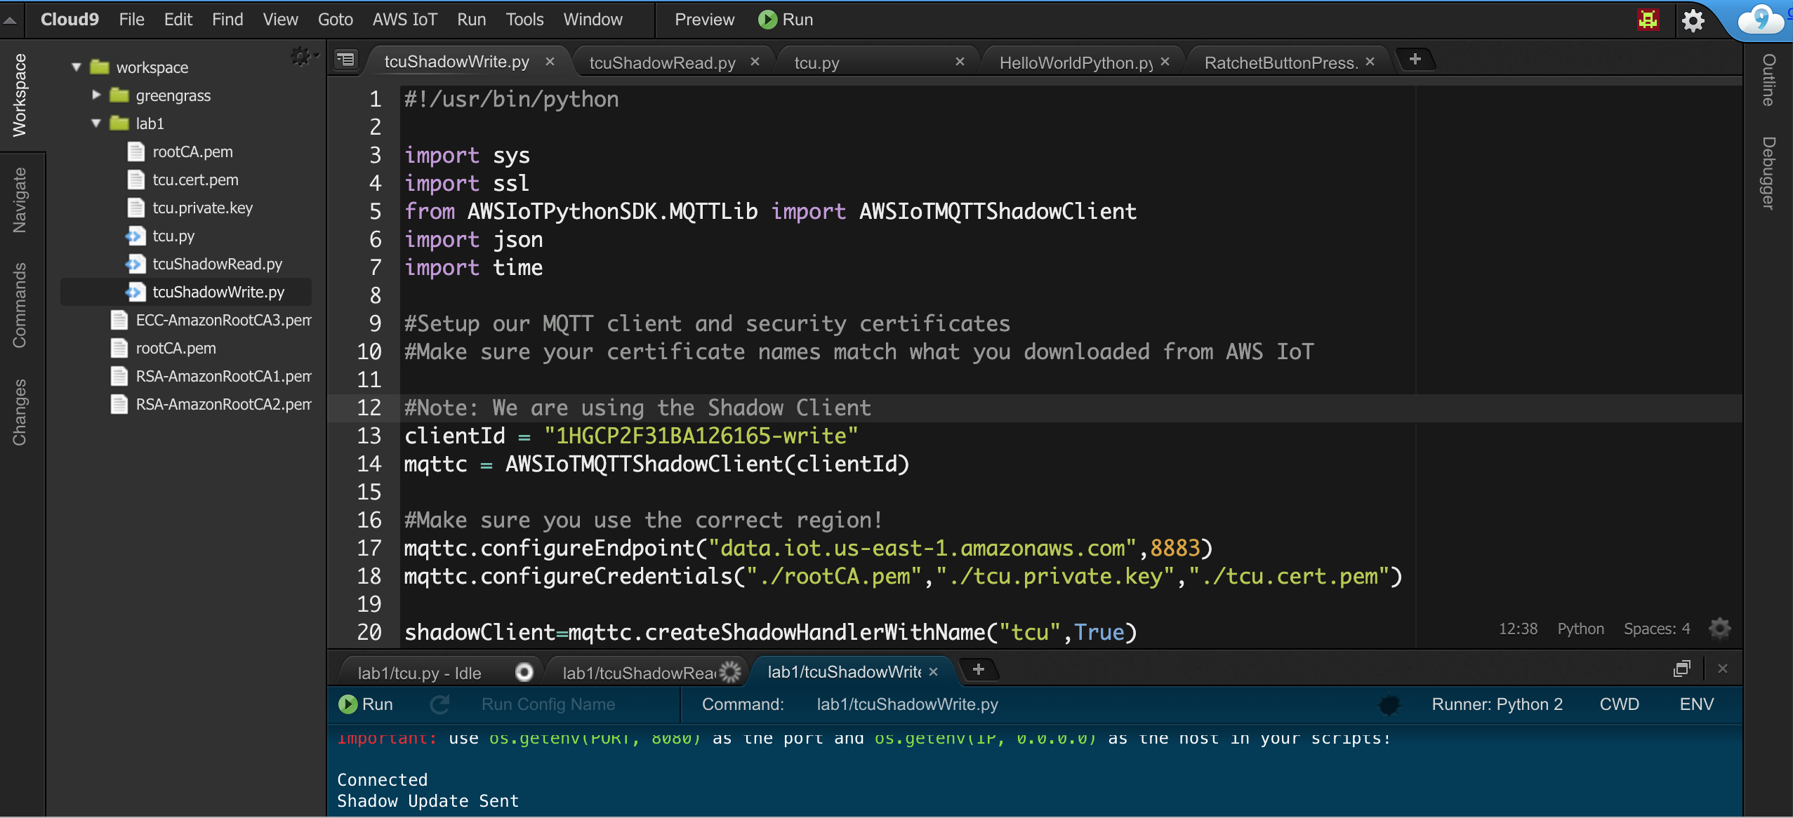

Open AWS IoT Core. Click **Manage** -> **Things** -> Select **tcu**, and then choose **Shadow.** You should be able to see the shadow message sent from the device.

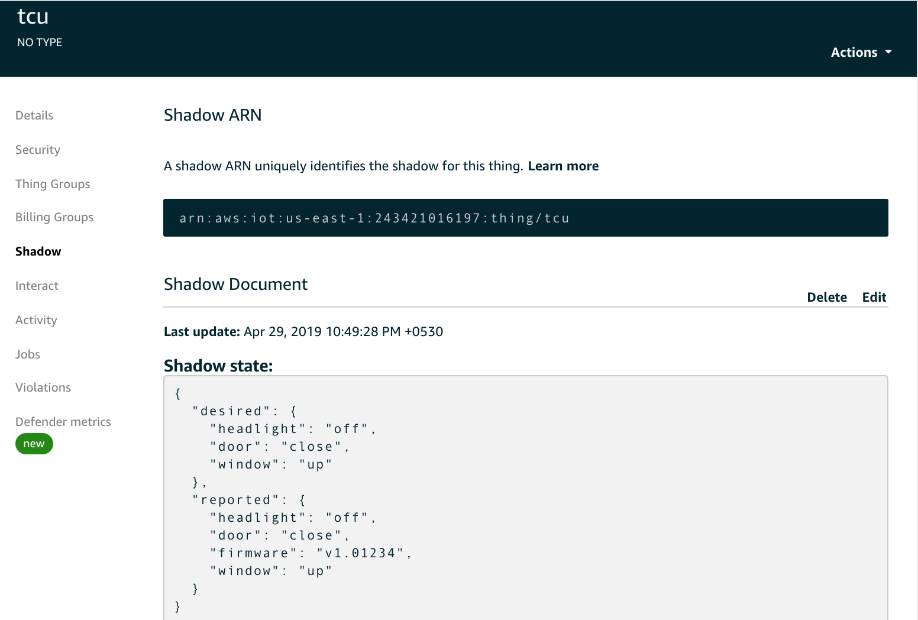

## Step 2 – Read Device Shadow

Now let’s read a shadow message at the device if it gets updated in the cloud. Create a new python file called **tcuShadowRead.py** in the **lab1** folder and copy the following code or use the downloaded file from pre-requisite:

#!/usr/bin/python

import sys

import ssl

from AWSIoTPythonSDK.MQTTLib import AWSIoTMQTTShadowClient

import json

import time

# Setup our MQTT client and security certificates# Make sure your certificate names match what you downloaded from AWS IoT

# Note: We are using the Shadow Client

clientId = "1HGCP2F31BA126165-read"

mqttc = AWSIoTMQTTShadowClient(clientId)

# Make sure you use the correct region!

mqttc.configureEndpoint("data.iot.us-east-1.amazonaws.com", 8883)

mqttc.configureCredentials("./rootCA.pem", "./tcu.private.key", "./tcu.cert.pem")

shadowClient = mqttc.createShadowHandlerWithName("tcu", True)

# Function to encode a payload into JSON

def json_encode(string):

return json.dumps(string)

mqttc.json_encode = json_encode

shadowClient.json_encode = json_encode

def on_message(message, response, token):

print "Received Delta : " + message

data = json.loads(message)

currentState = data.get('state')

#reportedShadowMessage = {"state":{"reported":{}}}

shadowClient.reportedShadowMessage = {"state":{"reported":{}}}

#handle each command

headlight_handle(currentState.get('headlight'))

window_handle(currentState.get('window'))

door_handle(currentState.get('door'))

msg = json.dumps(shadowClient.reportedShadowMessage)

#print msg

#Update the reported status to device shadow

shadowClient.shadowUpdate(msg,on_reported, 5)

def on_reported(message, response, token):

print "Reported state : " + response

def headlight_handle(status):

if status is not None:

shadowClient.reportedShadowMessage['state']['reported']['headlight'] = status

print 'Perform action on headlight status change: ' + str(status)

def window_handle(status):

if status is not None:

shadowClient.reportedShadowMessage['state']['reported']['window'] = status

print 'Perform action on window status change: ' + str(status)

def door_handle(status):

if status is not None:

shadowClient.reportedShadowMessage['state']['reported']['door'] = status

print 'Perform action on door status change: ' + str(status)

mqttc.on_message = on_message

shadowClient.on_message = on_message

mqttc.connect()

print "Connected"

shadowClient.shadowRegisterDeltaCallback(on_message)

print "Listening for Delta Messages"

# Loop forever

while True:

pass

Replace this VIN number with yours:

VIN = "1HGCP2F31BA126165-read"

Replace **tcu** with your **device name** in AWS IoT.

shadowClient = mqttc.createShadowHandlerWithName("tcu", True)

Now run the **tcuShadowRead.py** file.

Open AWS IoT Core. Click **Manage** -> **Things,** select **tcu,** and then choose **Shadow.** Click **Edit**, change the desired state of the headlight to on, and click **Save**.

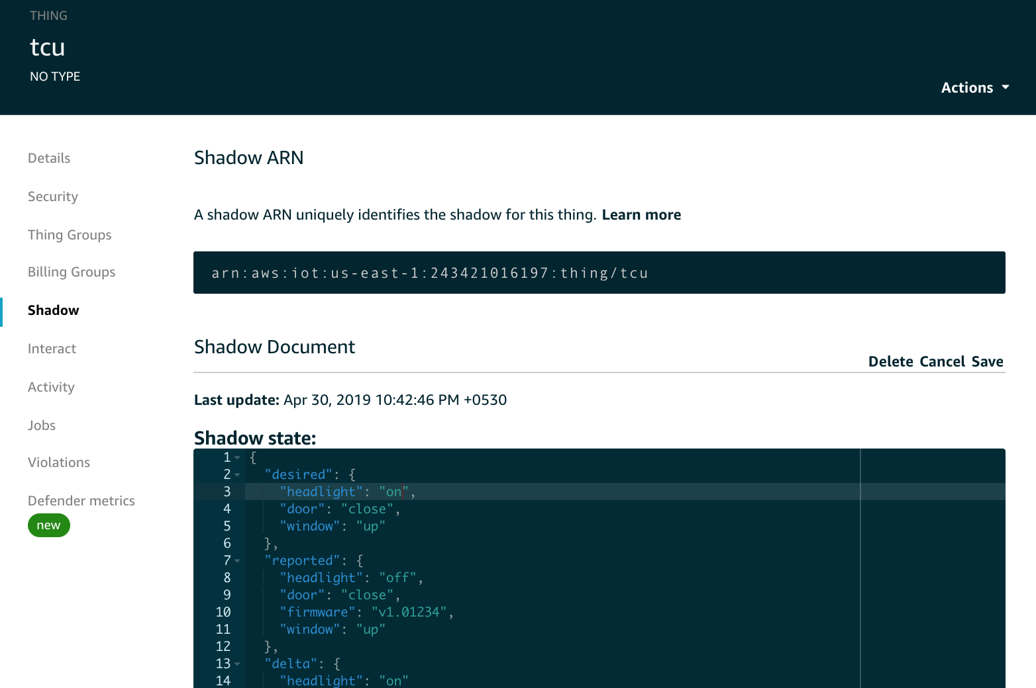

After you save, you should see the update on the Cloud9 IDE console as shown:

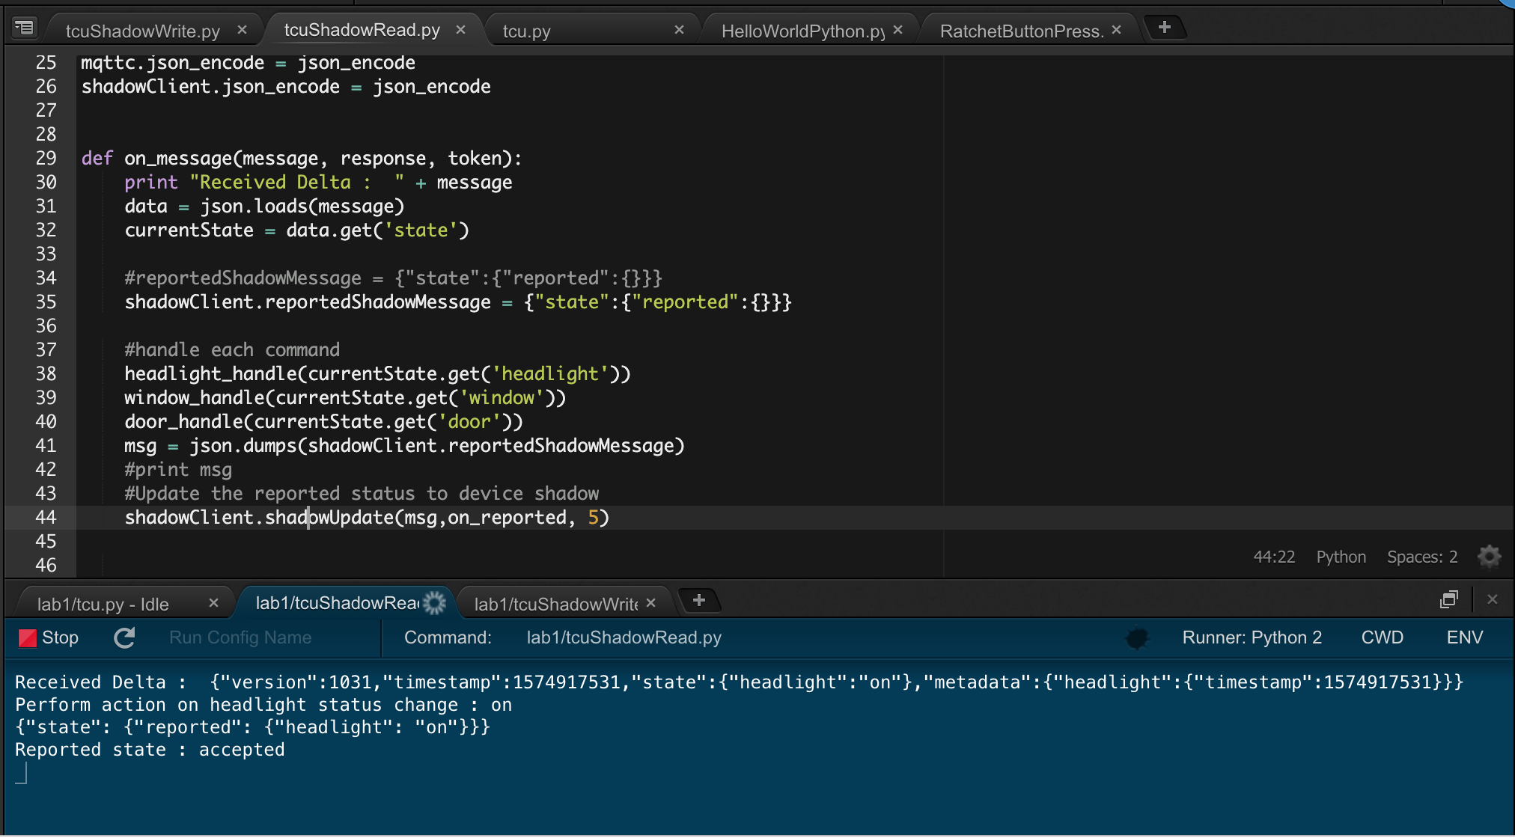

## Step 3 – Deploy virtual model of a vehicle

The three worlds of digital shadow will be represented here:

1. Environment setup with Cloud9 IDE is acting as physical entities in the real world
2. A web page will represent the Virtual models of a vehicle
3. And the connected data/view that ties both worlds. It is represented by the shadow message.

So far, we have looked into the 1) and 3) worlds as per the concept of digital shadow. Let’s set up a virtual model.

To simply the deployment, we will reuse the IoTSimulator website to deploy the code to represent the virtual model of a vehicle. It will allow us to reuse the configuration and IoT SDK.

1. Download the **demo-car.zip** file from <https://s3.amazonaws.com/smrt-parking/demo-car.zip>.

**Note:** The CodePen [project](https://codepen.io/YusukeNakaya/pen/ZadZxL), with minor changes, is used for the model.

1. The IoTSimulator creates an Amazon CloudFront endpoint and deploys website code in Amazon S3. You will have an S3 bucket called:

<*IoT simulator stack name*>-iotsimwebsitebucket-<*random character*>.us-east-1.amazonaws.com

1. Unzip the **demo-car.zip** file and upload it to S3 under the assets folder of IoT Simulator website. Or you can use AWS S3 sync command to upload the file.
2. Now open the file using the CloudFront endpoint:

https://<*random character*>.cloudfront.net/assets/demo-car/demo.html

You should see a page similar to the following:

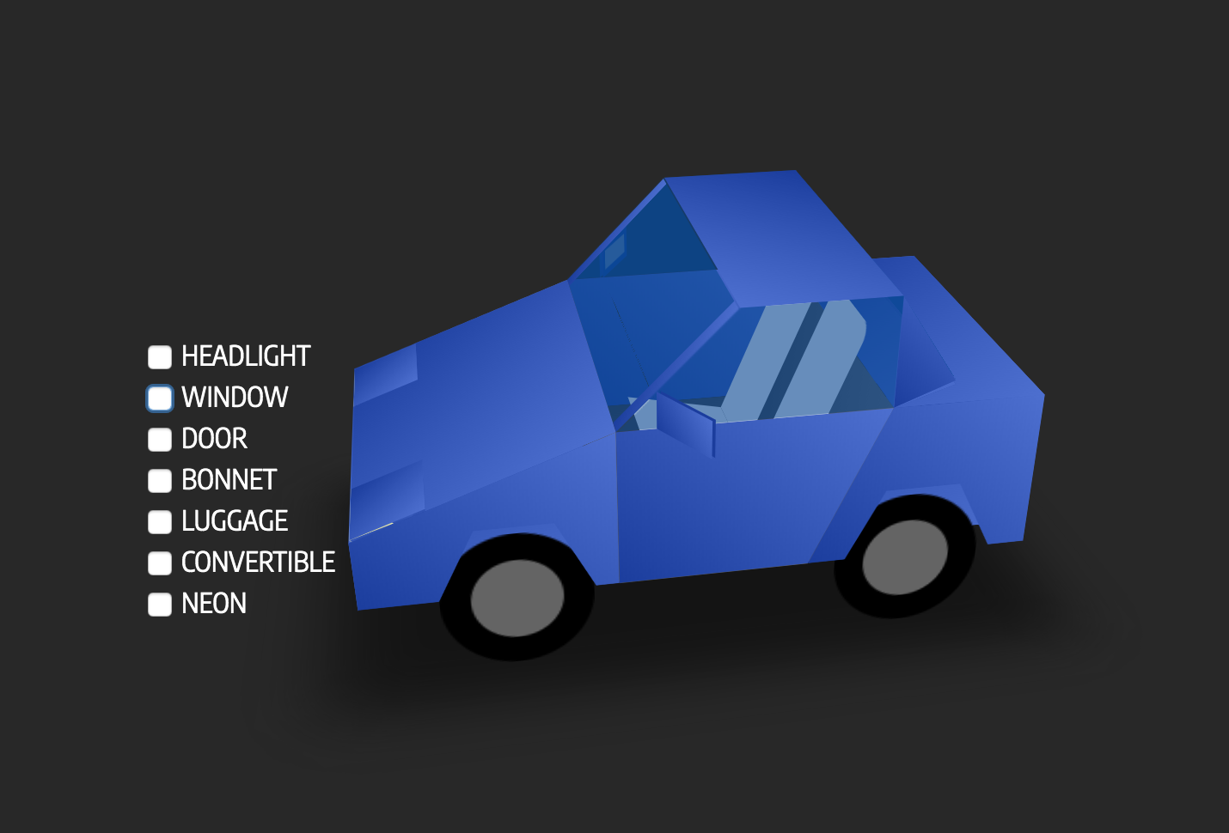

## Step 4 – Configure Virtual Model of a Vehicle

1. Create a JavaScript file called **demo-car.js** in the demo-car folder and paste in the following code or use the downloaded code from pre-requisite. This file includes the functions that our simulated vehicle will use in order to change the device shadow.

**Note**: JS double quote (") might convert into word double quote (“). Pls change.

var demoCar = {

shadowMessage : {

"state" :

{

"reported" :

{

"firmware" : 'v1.01234'

},

"desired":{}

}

},

// Create a client id to use when connecting to AWS IoT.

_clientId :'1HGCP2F31BA126165-Web',

// Create the AWS IoT device object. Note that the credentials must be

// initialized with empty strings; when we successfully authenticate to

// the Cognito Identity Pool, the credentials will be dynamically updated.

webClient : new AWS.IotData({

// Set the AWS region we will operate in.

region: appVariables.REGION,

////Set the AWS IoT Host Endpoint

endpoint:appVariables.IOT_ENDPOINT,

// Use the clientId created earlier.

clientId: this._clientId,

// Connect via secure WebSocket

protocol: 'wss',

// Set the maximum reconnect time to 8 seconds; this is a browser application

// so we don't want to leave the user waiting too long for reconnection after

// re-connecting to the network/re-opening their laptop/etc...

maximumReconnectTimeMs: 8000,

// Enable console debugging information (optional)

debug: true,

// IMPORTANT: the AWS access key ID, secret key, and sesion token must be

// initialized with empty strings.

accessKeyId: '',

secretKey: '',

sessionToken: ''

}),

//this function will get called when user will click on door checkbox

handleDoorCommand: function(obj) {

obj.checked ? demoCar.shadowMessage.state.desired.door = "open" : demoCar.shadowMessage.state.desired.door = "close";

console.log(obj.getAttribute("data-text") + " : " + demoCar.shadowMessage.state.desired.door);

demoCar.accessIoTDevice();

},

//this function will get called when user will click on window checkbox

handleWindowCommand : function(obj) {

obj.checked ? demoCar.shadowMessage.state.desired.window = "down" : demoCar.shadowMessage.state.desired.window = "up";

console.log(obj.getAttribute("data-text") + " : " + demoCar.shadowMessage.state.desired.window);

demoCar.accessIoTDevice();

},

//this function will get called when user will click on headlight checkbox

handleHeadLightCommand : function(obj) {

obj.checked ? demoCar.shadowMessage.state.desired.headlight = "on" : demoCar.shadowMessage.state.desired.headlight = "off";

console.log(obj.getAttribute("data-text") + " : " + demoCar.shadowMessage.state.desired.headlight);

demoCar.accessIoTDevice();

},

// Called to use UnAuth role to access IoT service

accessIoTDevice: function() {

//Create Identity credentials

AWS.config.region = appVariables.REGION;

AWS.config.credentials = new AWS.CognitoIdentityCredentials( { IdentityPoolId : appVariables.IDENTITY_POOL_ID});

// Obtain AWS credentials

AWS.config.credentials.get(function () {

//Connect the IoT using this credentials

//demoCar.connectDevice(AWS.config.credentials.accessKeyId, AWS.config.credentials.secretAccessKey, AWS.config.credentials.sessionToken);

demoCar.webClient.config.credentials = AWS.config.credentials;

demoCar.connectDevice();

//Connect for two way if its not connected.

if(!CONNECTED)

{

connectDeviceTwoWay(AWS.config.credentials);

}

});

},

connectDevice : function()

{

var params = {

payload: JSON.stringify(demoCar.shadowMessage) /* Strings will be Base-64 encoded on your behalf */, /* required */

thingName: 'tcu' /* required */

};

demoCar.webClient.updateThingShadow(params, function(err, data) {

if (err) console.log(err, err.stack); // an error occurred

else console.log(data);

// successful response

//reset the local shadow state

demoCar.shadowMessage.state.desired = {}

});

},

}

1. Let’s look at the code:
2. In **shadowMessage**, desired state is empty. It will be set during runtime.
3. **_CliendId** should be unique so put your VIN number below
4. We have 3 handle command function defined (e.g., handleDoorCommand) to take the user input and access AWS IoT Core services. Here we are using the Cognito UnAuth role to access IoTCore.
5. **connectDevice** is an actual function to invoke **updateThingsShadow** function to send the desired state
6. Edit **demo.html** file and add the following script under <head>. We are reusing the SDK and **appVariables.js** file of the IoT Simulator.

<!--add below scripts to access AWS IoT services and application logic-->

<script src="../aws-sdk.min.js"></script>

<script src="../aws-iot/aws-iot.js"></script>

<script src="../appVariables.js"></script>

<script src="demo-car.js"></script>

1. Add **onclick** handlers for **headlight**, **window**, and **door** to invoke the appropriate function, such as demoCar.handleHeadLightCommand(this) for **headlight**, as shown below:

<input class="action headlight" type="checkbox" data-text="HEADLIGHT" onclick='demoCar.handleHeadLightCommand(this);'/>

<input class="action window" type="checkbox" data-text="WINDOW" onclick='demoCar.handleWindowCommand(this);'/>

<input class="action door" type="checkbox" data-text="DOOR" onclick='demoCar.handleDoorCommand(this);'/>

1. Now let’s allow UnAuth role to access IoT services.
2. Open Cognito > Manage Identity Pools > IoT_Device_Simulator_Pool > Edit identity pool

You need to enable “Enable access to unauthenticated identities” checked and click on ‘**Create new role**’ for Unauthenticated role.

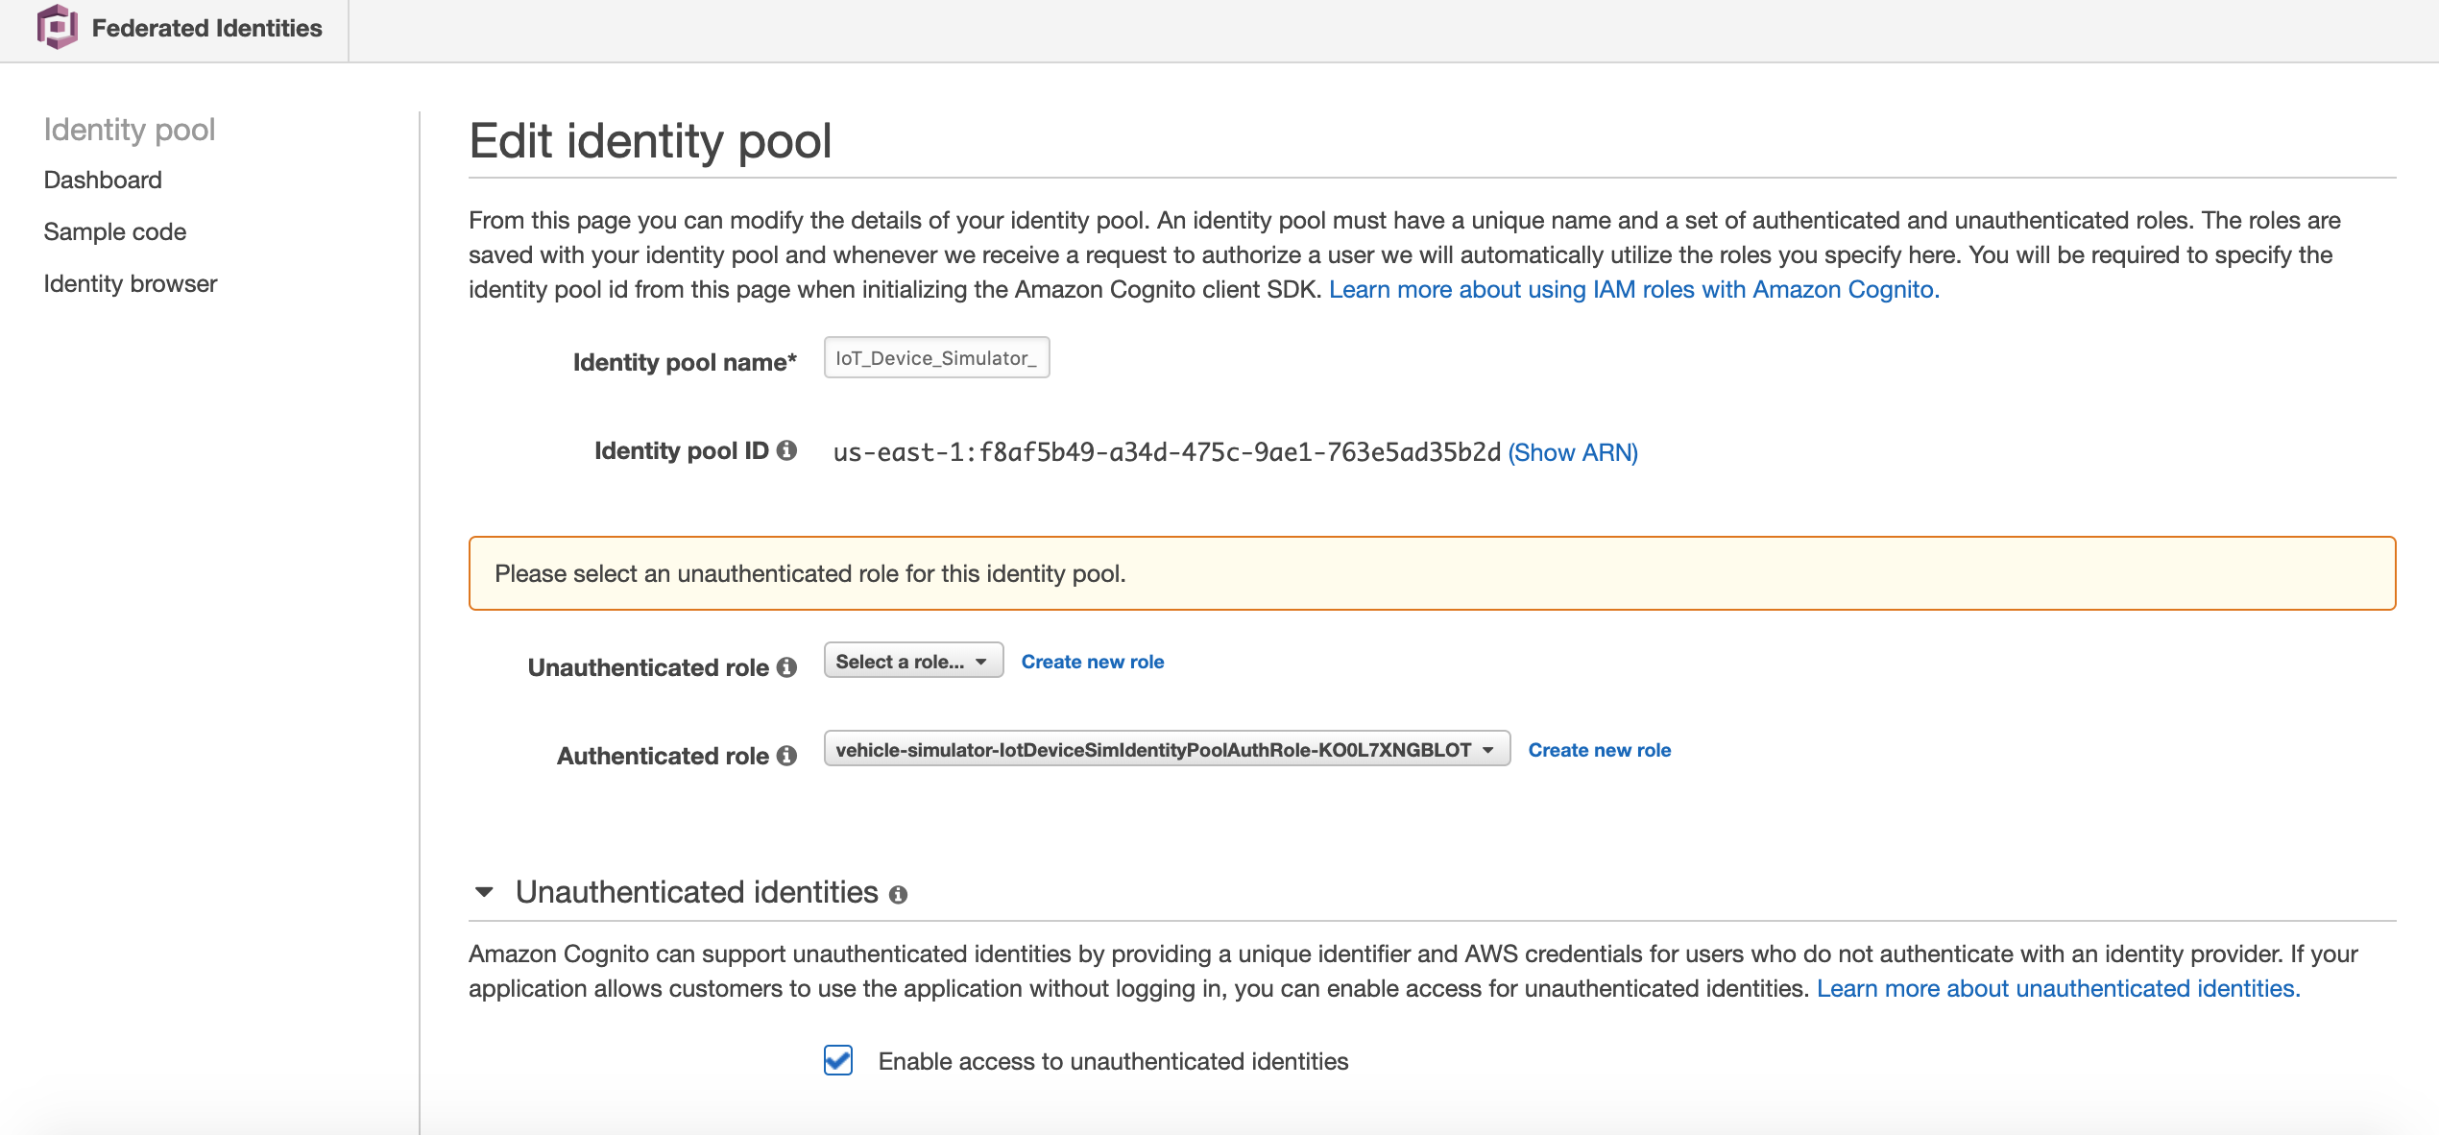

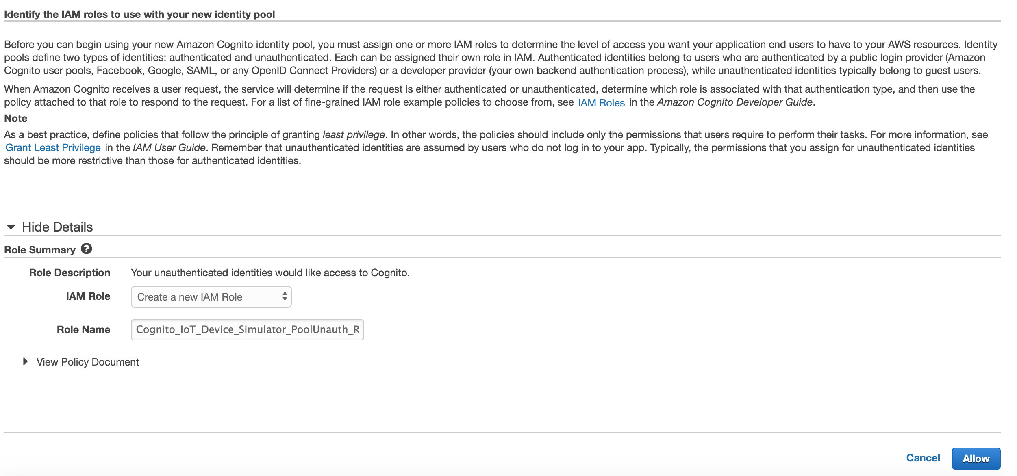

Click on Allow

1. Go into IAM role and search for UnAuth you have created. You will find a role something like below. Open the role page.

<IoT simulator stack name>-IotDeviceSimIdentityPoolUnauthRole-<XDEXXXXWKQX>

Alternatively, you can find the exact UnAuth role from the Cognito Identity pool page. IoT Simulator creates IoT_Device_Simulator_Pool

Note: To simplify the lab, we are using UnAuth role otherwise Auth role is recommended for proof of concept and production environments.

1. Expand the attached policy and select **Edit** Policy under the **Permissions** tab.
2. Add the permission for **GetThingsShadow** and **UpdateThingsShadow.** This policy will allow the following actions:

"Action": [

"iot:Receive",

"iot:Subscribe",

"iot:Connect",

"iot:GetThingShadow",

"iot:UpdateThingShadow"

]

Now the UnAuth role has sufficient permissions to connect to IoTCore and send / receive Things shadow.

## Step 5 – Run the Vehicle

In this step, we will run the demo model of the vehicle and execute the code at **tcu**. State change of the vehicle model should be reached to **tcu** to act on the message.

1. Now let’s open the **demo.html** using the CloudFront URL of the simulator website (deployed earlier) <https://xxxxxxxx.cloudfront.net/assets/demo-car/demo.html>
2. Delete the existing shadow message to ensure current and previous state is not affecting the output. Click **IoT Core** -> **Manage** -> **Things** -> **tcu** -> **Shadow** -> **Delete.**

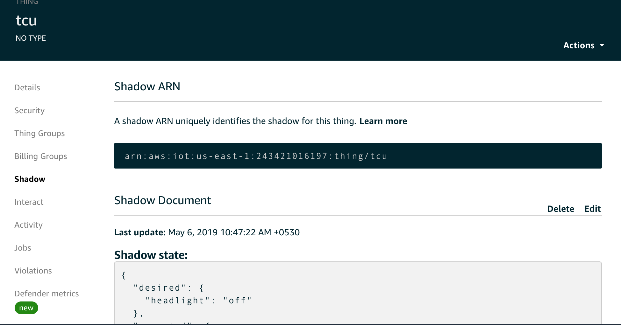

1. Run the **tcuShadowReady.py** script in Cloud9 IDE.

**shadowRegisterDeltaCallback** will listen on delta topics for this device shadow by subscribing to delta topics. Callback will be fired whenever there is a difference between the desired and reported state.

1. 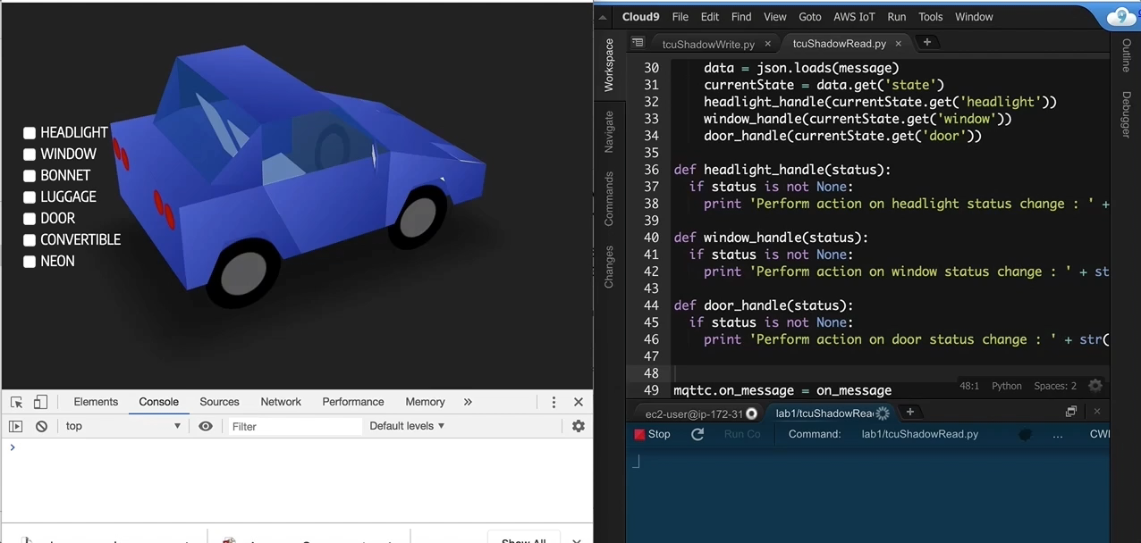Now change the headlight on the demo car virtual model. Keep the Cloud9 IDE and **demo.html** side by side. You should be able to view the change as shown below:

## Step 6 – Configure Two-Way Communication

AWS IoT supports websockets over mqtt. Currently the JavaScript SDK doesn’t support websocket. Therefore, we will use an open source Eclipse Paho script to make it happen.

Create a new JavaScript file named **webSocketApp.js** and paste in the code shown or use the downloaded code from pre-requisite:

var CONNECTED = false;

/**

* utilities to do sigv4

* @class SigV4Utils

*/

function SigV4Utils() {}

SigV4Utils.getSignatureKey = function (key, date, region, service) {

var kDate = AWS.util.crypto.hmac('AWS4' + key, date, 'buffer');

var kRegion = AWS.util.crypto.hmac(kDate, region, 'buffer');

var kService = AWS.util.crypto.hmac(kRegion, service, 'buffer');

var kCredentials = AWS.util.crypto.hmac(kService, 'aws4_request', 'buffer');

return kCredentials;

};

SigV4Utils.getSignedUrl = function(host, region, credentials) {

var datetime = AWS.util.date.iso8601(new Date()).replace(/[:\-]|\.\d{3}/g, '');

var date = datetime.substr(0, 8);

var method = 'GET';

var protocol = 'wss';

var uri = '/mqtt';

var service = 'iotdevicegateway';

var algorithm = 'AWS4-HMAC-SHA256';

var credentialScope = date + '/' + region + '/' + service + '/' + 'aws4_request';

var canonicalQuerystring = 'X-Amz-Algorithm=' + algorithm;

canonicalQuerystring += '&X-Amz-Credential=' + encodeURIComponent(credentials.accessKeyId + '/' + credentialScope);

canonicalQuerystring += '&X-Amz-Date=' + datetime;

canonicalQuerystring += '&X-Amz-SignedHeaders=host';

var canonicalHeaders = 'host:' + host + '\n';

var payloadHash = AWS.util.crypto.sha256('', 'hex')

var canonicalRequest = method + '\n' + uri + '\n' + canonicalQuerystring + '\n' + canonicalHeaders + '\nhost\n' + payloadHash;

var stringToSign = algorithm + '\n' + datetime + '\n' + credentialScope + '\n' + AWS.util.crypto.sha256(canonicalRequest, 'hex');

var signingKey = SigV4Utils.getSignatureKey(credentials.secretAccessKey, date, region, service);

var signature = AWS.util.crypto.hmac(signingKey, stringToSign, 'hex');

canonicalQuerystring += '&X-Amz-Signature=' + signature;

if (credentials.sessionToken) {

canonicalQuerystring += '&X-Amz-Security-Token=' + encodeURIComponent(credentials.sessionToken);

}

var requestUrl = protocol + '://' + host + uri + '?' + canonicalQuerystring;

console.log(requestUrl);

return requestUrl;

};

var connectOptions = {

onSuccess: function(){

console.log("onSuccess called")

onConnect();

},

useSSL: true,

timeout: 3,

mqttVersion: 4,

onFailure: function() {

console.log("onFailure called")

}

};

var client;

function connectDeviceTwoWay(credentials)

{

//get the url

requestUrl = SigV4Utils.getSignedUrl (appVariables.IOT_ENDPOINT, appVariables.REGION, credentials)

clientId = "1HGCP2F31BA126165-WebTwoWay"

// Create a client instance

client = new Paho.MQTT.Client(requestUrl, clientId);

// set callback handlers

client.onConnectionLost = onConnectionLost;

client.onMessageArrived = onMessageArrived;

// connect the client

client.connect(connectOptions);

}

// called when the client connects

function onConnect() {

// Once a connection has been made, make a subscription and send a message.

console.log("onConnect");

CONNECTED = true;

client.subscribe("$aws/things/tcu/shadow/update/accepted");

}

// called when the client loses its connection

function onConnectionLost(responseObject) {

CONNECTED = false;

if (responseObject.errorCode !== 0) {

console.log("onConnectionLost:" + responseObject.errorMessage);

}

}

// called when a message arrives

function onMessageArrived(message) {

CONNECTED = true;

console.log("onMessageArrived:" + message.payloadString);

payload = JSON.parse(message.payloadString);

payloadData = payload.state.reported == undefined ? payload.state : payload.state.reported

payloadData = payloadData.desired == undefined ? payload.state : payload.state.desired

if (payloadData.window != undefined) handleWindowCommand(payloadData.window);

if (payloadData.door != undefined) handleDoorCommand(payloadData.door);

if (payloadData.headlight != undefined) handleHeadlightCommand(payloadData.headlight);

}

//this function will get called when user will click on window checkbox

function handleWindowCommand (windowStatus) {

obj = document.getElementsByClassName("action window")[0];

obj.checked = windowStatus == "down" ? true : false;

console.log(obj.getAttribute("data-text") + " : " + obj.checked);

}

//this function will get called when user will click on door checkbox

function handleDoorCommand (doorStatus) {

obj = document.getElementsByClassName("action door")[0];

obj.checked = doorStatus == "open" ? true : false;

console.log(obj.getAttribute("data-text") + " : " + obj.checked);

}

//this function will get called when user will click on Headlight checkbox

function handleHeadlightCommand (headlightStatus) {

obj = document.getElementsByClassName("action headlight")[0];

obj.checked = headlightStatus == "on" ? true : false;

console.log(obj.getAttribute("data-text") + " : " + obj.checked);

}

Let’s look at the code:

* **SigV4Utils.getSignatureKey** and **SigV4Utils.getSignedUrl** are utility functions used in generating a Signature Version 4 request. The WebSocket implementation provided by most web browsers does not allow the modification of HTTP headers, so it is necessary to add the Signature Version 4 information to the query string.
* Update the **ClientId** with VIN in the **connectDeviceTwoWay** function to ensure it is unique.
* **onConnect()** function subscribes to IoT Core topics “aws/things/<*thingName*>/shadow/update/accepted". In this lab, *thingName* is **tcu**. We are subscribing to the shadow update accepted. The Device Shadow service sends messages to this topic when an update is successfully made to the device's shadow.
* **onMessageArrived()** function will be invoked whenever the device will change the shadow state.
* **handle<*object*>Command** functions (such as **handleDoorCommand**) will be called with the current state.

1. Open a **demo.html page** to add Eclipse Paho script copy the below code and paste under the <head> tag:

<!--Added Eclipse Paho script for WebScoket MQTT-->

<script src="https://cdnjs.cloudflare.com/ajax/libs/paho-mqtt/1.0.1/mqttws31.js" type="text/javascript"></script>

1. Open the **demo-car.js** file and uncomment the following code:

//Connect for two way if its not connected.

if(!CONNECTED)

{

connectDeviceTwoWay(AWS.config.credentials);

}

1. Now add the **webSocketApp.js** script in the **demo.html** file before **demo-car.js**:

<script src="webSocketApp.js"></script>

<script src="demo-car.js"></script>

1. The c**onnectDeviceTwoWay** function in **webSocketApp.js** gets called for the first time to establish the mqtt connect over websocket. After establishing the connection, CONNECTED is always true. You can also establish the connection during page load with <body onload="demoCar.accessIoTDevice();"> in the **demo.html**
2. 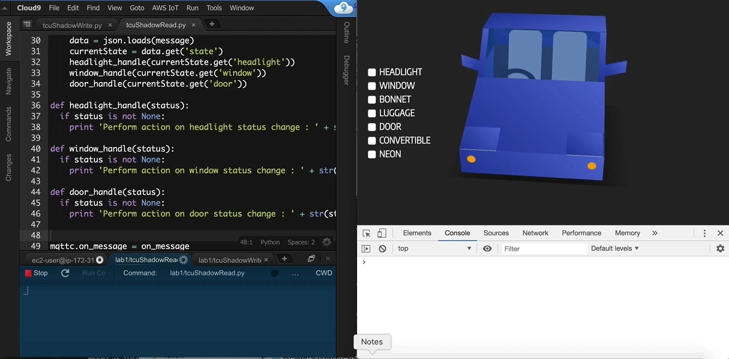Now keep both Cloud9 IDE and **demo.html** side by side and run the **tcuShadowRead.py** script.
3. Open the **tcuShadowWrite.py** file and change the desired state of door to open, headlight to on, and window to up and click **Save.**

"desired":{

"door":'open',

"headlight" : 'on',

"window" : 'up'

}

1. Click **Run** to execute the **tcuShadowWrite.py** script. You should be able to see the update on the **demo.html** page.

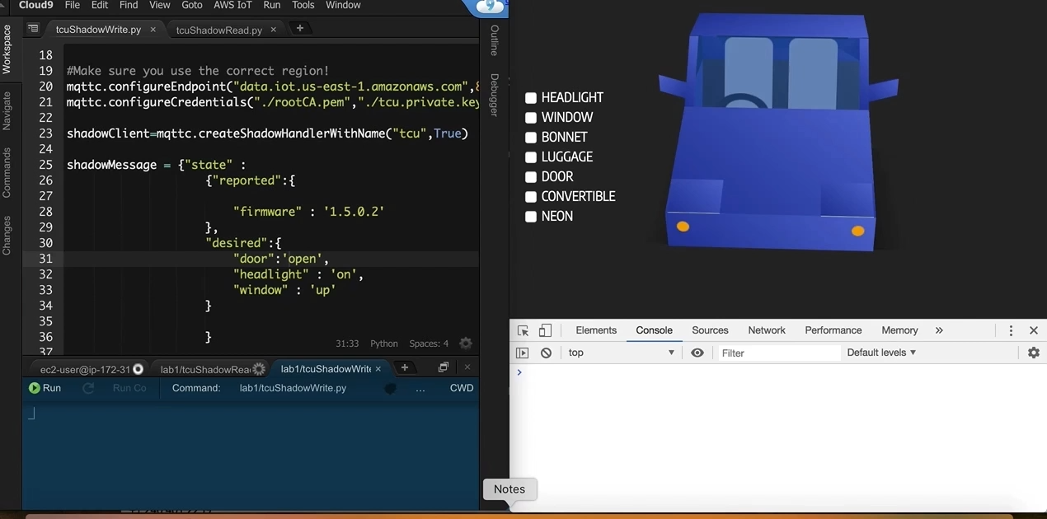

## Step 7 – Optional Steps

Follow the above steps and make the vehicle model respond to the Convertible, Neon, Luggage, and Bonnet actions.

## Step 8 – Debug

If you are unable to see any updates on the **demo.html** page, subscribe to the shadow document in AWS IoT test.

$aws/things/<thingName>/shadow/update/documents

This document will help you understand the message exchange.

Two-way communication gets established in the first invocation of the command. Therefore, always click the checkbox and get the **tcuShadowRead.py** working before executing **tcuShadowWrite.py** code.

# Notices

Customers are responsible for making their own independent assessment of the information in this document. This document: (a) is for informational purposes only, (b) represents current AWS product offerings and practices, which are subject to change without notice, and (c) does not create any commitments or assurances from AWS and its affiliates, suppliers or licensors. AWS products or services are provided “as is” without warranties, representations, or conditions of any kind, whether express or implied. The responsibilities and liabilities of AWS to its customers are controlled by AWS agreements, and this document is not part of, nor does it modify, any agreement between AWS and its customers.

© 2019 Amazon Web Services, Inc. or its affiliates. All rights reserved.